Practical 3
- Demonstrate Linear Search in an array with 10 elements
Code – #include<iostream.h>
#include<conio.h>
void main()
{
clrscr();
int a[20],n,item,i,flag=0;
cout<<"enter total number of elements: ";
cin>>n;
cout<<endl;
cout<<"enter the elements: ";
for(i=0;i<n;i++)
{
cin>>a[i];
}
cout<<endl;
cout<<"enter the element to be searched: ";
cin>>item;
cout<<endl;
for(i=0;i<n;i++)
{
if(a[i]==item)
{
cout<<"element is found at position "<<i+1;
flag=1;
break;
}
}
if(flag==0)
{
cout<<"desired element is not found in the array! ";
}
getch();
}

Output – 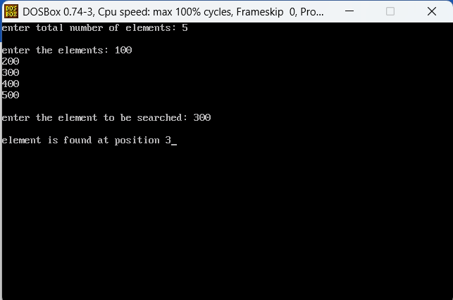

- Demonstrate Binary Search.
Code – #include<iostream.h>
#include<conio.h>
void main()
{
clrscr();

int a[20],i,num,n,count=0,position;
cout<<"enter total number of element: ";
cin>>n;
cout<<endl;
cout<<"eneter elements: ";
for(i=0;i<n;i++)
{
cin>>a[i];
}
cout<<endl;
cout<<"enter element to be searched: ";
int s,first, last, mid;
cin>>s;
cout<<endl;
first=0;
last=n-1;
mid=(first+last)/2;
while(first<=last)
{
if(a[mid]<s)
{
first=mid+1;
}
else if(a[mid]==s)
{
cout<<s<<" found at "<<mid+1<<endl;
count=1;
break;
}
else
{
last=mid-1;
}
mid=(first+last)/2;
}
if(count==0)
{
cout<<"desired elemnt is not found in the array!";
}
getch();
}

Output – 